**CSE321 Lab Assignment 1**

**Tahsin Ashrafee Susmit**

**ID: 20301088**

**1 (a)**

**Create 4 files named yourID_1.txt, yourID_2.txt, yourID_3, yourID_4.txt**

touch 20301088_1.txt 20301088_2.txt 20301088_3.txt 20301088_4.txt

**Create 2 directories named YourName1, YourName2**

mkdir TahsinAshrafee1 TahsinAshrafee2

**Move yourID_1.txt, yourID_2.txt, yourID_3.txt in YourName1 directory**

mv 20301088_1.txt 20301088_2.txt 20301088_3.txt TahsinAshrafee1

**Copy yourID_1.txt, yourID_2.txt YourName2 directory.**

cp TahsinAshrafee1/20301088_1.txt TahsinAshrafee1/20301088_2.txt TahsinAshrafee2

**Create another directory YourName3**

mkdir TahsinAshrafee3

**Copy the YourName1 directory along with its contents to the YourName3 directory**

cp -r TahsinAshrafee1 TahsinAshrafee3

**Go into the YourName3 directory and check the permissions of the files/directory and change the permissions for both groups and others to only read-execute for all the files.**

cd TahsinAshrafee3

ls -l

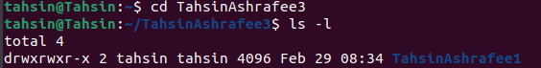

chmod -R go=rx *

ls -l

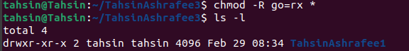

**Go back to one directory and print all the directories and files in the current working**

**directory**

cd ..

ls



**Move the YourName3 folder to the root directory and delete the rest of the**

**files and folders in the current working directory**

mv TahsinAshrafee3 root

rm -r *

**(b)**

touch course.txt

cat>course.txt

CSE321 OS 4

CSE421 Computer Networks 3

CSE461 Robotics 1

CSE400 Thesis 0

[CTRL + D]

grep -c "CSE" course.txt

grep -n "CSE" course.txt

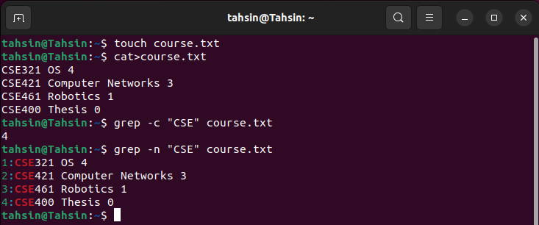

**(c) Show all the hidden files in your root directory**

ls -a /

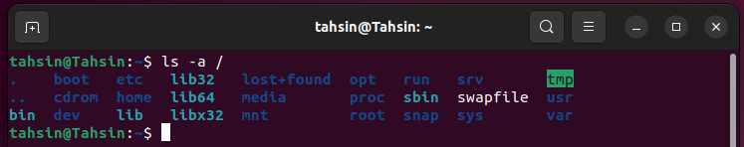

**(d) Show only lines 5-17 of a .txt file(you have to create a file containing more than 17 line)**

sed -n '5,17p' line.txt

